***NESNEL TABANNLI PROGRAMLA 1 PROJE ÖDEVİ***

**ADI :** MERT

**SOYADI :** RAMAZANOĞLU

**NO :** 2012730039

**SINIF / ŞUBE :** 2.SINIF-A ŞUBESİ

**BÖLÜM :** BİLGİSAYAR PROGRAMCILIĞI (İKİNCİ ÖĞRETİM)

**PROJENİN ADI :** İş çalışma saatlerinde işten kaytarmaya çalışan işçilerin maaşından kesintiye uğratma.

**Projenin Kısa Özeti :** İş saatlerinde belli bir alanda çalışıp kaytaran bir işçinin sensörlü devre vasıtası ile program çalışıp hesaplamalar yapılacaktır.

**DERS ÖĞRETMENİ :** İSMAİL DÜŞMEZ

FORM 1 KODLARI VE EKRAN YAPISI

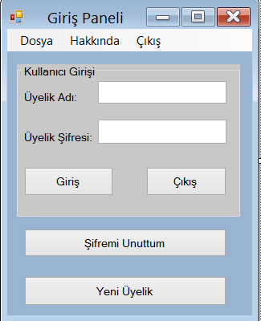

Imports System.Data.OleDb

Public Class Form1

Private Sub Button1_Click(ByVal sender As System.Object, ByVal e As System.EventArgs) Handles Button1.Click

Dim baglan As New OleDbConnection

Dim komut As New OleDbCommand

Dim adap As New OleDbDataAdapter

Dim dataset As New DataSet

baglan.ConnectionString = ("Provider=Microsoft.ACE.OLEDB.12.0;Data Source=uye_panel.accdb")

komut.CommandText = ("select * from tablo where uye_adi='" + TextBox1.Text + "' and uye_sifre='" + TextBox2.Text + "'")

baglan.Open()

komut.Connection = baglan

adap.SelectCommand = komut

adap.Fill(dataset, "0")

Dim a = dataset.Tables(0).Rows.Count

If a > 0 Then

Form2.Show()

Me.Hide()

Else

MessageBox.Show("Üyelik adınızı veya üyelik şifrenizi yanlış yazdınız.Tekrar yazınız.", "Yanlış Üyelik Girişi", MessageBoxButtons.OK, MessageBoxIcon.Warning)

TextBox1.Clear()

TextBox2.Clear()

Me.Show()

End If

End Sub

Private Sub Button3_Click(ByVal sender As System.Object, ByVal e As System.EventArgs) Handles Button3.Click

Me.Hide()

Form3.ShowDialog()

End Sub

Private Sub Button4_Click(ByVal sender As System.Object, ByVal e As System.EventArgs) Handles Button4.Click

Me.Hide()

Form4.ShowDialog()

End Sub

Private Sub Form1_Load(ByVal sender As System.Object, ByVal e As System.EventArgs) Handles MyBase.Load

TextBox1.Clear()

TextBox2.Clear()

End Sub

Private Sub Button2_Click(ByVal sender As System.Object, ByVal e As System.EventArgs) Handles Button2.Click

Select Case MessageBox.Show("Çıkmak İstiyormusunuz?", "Çıkış Uyarısı", MessageBoxButtons.YesNo, MessageBoxIcon.Question)

Case DialogResult.Yes

Application.Exit()

Case Else

Me.Show()

End Select

End Sub

Private Sub Form1_Activated(ByVal sender As System.Object, ByVal e As System.EventArgs) Handles MyBase.Activated

TextBox1.Clear()

TextBox2.Clear()

End Sub

Private Sub ÇıkışToolStripMenuItem1_Click(ByVal sender As System.Object, ByVal e As System.EventArgs) Handles ÇıkışToolStripMenuItem1.Click

Select Case MessageBox.Show("Çıkmak İstiyormusunuz?", "Çıkış Uyarısı", MessageBoxButtons.YesNo, MessageBoxIcon.Question)

Case DialogResult.Yes

Application.Exit()

Case Else

Me.Show()

End Select

End Sub

Private Sub YeniÜyelikToolStripMenuItem_Click(ByVal sender As System.Object, ByVal e As System.EventArgs) Handles YeniÜyelikToolStripMenuItem.Click

Form4.ShowDialog()

End Sub

Private Sub ŞifremiUnuttumToolStripMenuItem_Click(ByVal sender As System.Object, ByVal e As System.EventArgs) Handles ŞifremiUnuttumToolStripMenuItem.Click

Form3.ShowDialog()

End Sub

Private Sub TelifHakkıToolStripMenuItem_Click(ByVal sender As System.Object, ByVal e As System.EventArgs) Handles TelifHakkıToolStripMenuItem.Click

MsgBox("Bu proje tüm hakları gizlidir.Çoğaltmak kesinlikle yasaktır.Gerekli hükümlere uyulmadığı sürece yasal işlem başlatıcaktır.")

End Sub

Private Sub YardımToolStripMenuItem_Click(ByVal sender As System.Object, ByVal e As System.EventArgs) Handles YardımToolStripMenuItem.Click

MsgBox("Bu proje yapanı için irtibata geçmek için m.rmnzoglu@hotmail.com adresine mail atabilirsiniz.")

End Sub

End Class

FORM 2 KODLARI VE EKRAN YAPISI

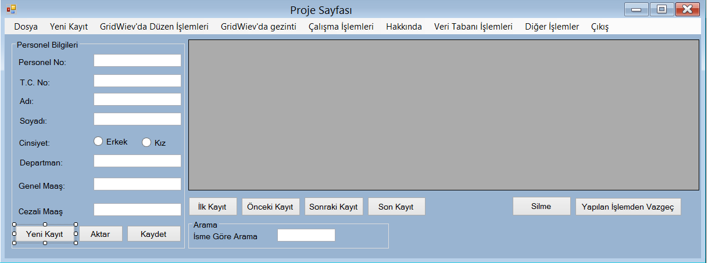

Imports System.Data.OleDb

Public Class Form2

Dim baglan As OleDbConnection

Dim komut As New OleDbCommand

Dim secilen As String

Dim cins As String

Dim kaynak As String = "Provider=Microsoft.ACE.Oledb.12.0;Data Source=proje.accdb"

Private Sub Form2_FormClosed(ByVal sender As System.Object, ByVal e As System.Windows.Forms.FormClosedEventArgs) Handles MyBase.FormClosed

Form1.Show()

End Sub

Private Sub Button2_Click(ByVal sender As System.Object, ByVal e As System.EventArgs) Handles Button2.Click

If Len(TextBox2.Text) < 12 Then

MsgBox("T.c. 11 haneden küçüktür")

Else

BindingSource1.EndEdit()

End If

End Sub

Private Sub Button1_Click(ByVal sender As System.Object, ByVal e As System.EventArgs) Handles Button1.Click

BindingSource1.AddNew()

RadioButton1.Checked = False

RadioButton2.Checked = False

End Sub

Private Sub ÇıkışToolStripMenuItem1_Click(ByVal sender As System.Object, ByVal e As System.EventArgs)

Me.Close()

Form1.Show()

End Sub

Private Sub TelifHakkıToolStripMenuItem_Click(ByVal sender As System.Object, ByVal e As System.EventArgs) Handles TelifHakkıToolStripMenuItem.Click

MsgBox("Bu programın telif hakları saklıdır.")

End Sub

Private Sub ProgramHakkındaToolStripMenuItem_Click(ByVal sender As System.Object, ByVal e As System.EventArgs) Handles ProgramHakkındaToolStripMenuItem.Click

MsgBox("Bu programın çalışma saatlerinde kaytarmaya çalışan kişilerin maaşlarından ceza olarak indirmek amaçlı yazılmıştır.")

End Sub

Private Sub Form2_Load(ByVal sender As System.Object, ByVal e As System.EventArgs) Handles MyBase.Load

TextBox2.MaxLength = 11

Dim baglan As New OleDbConnection(kaynak)

Dim adap As New OleDbDataAdapter("select * from personel", kaynak)

Dim tablo As New DataTable()

Dim ds As New DataSet()

adap.Fill(ds, "tablo")

ds.Tables.Add(tablo)

BindingSource1.DataSource = ds

BindingSource1.DataMember = ds.Tables(0).TableName

DataGridView1.DataSource = BindingSource1

TextBox1.DataBindings.Add("text", BindingSource1, "personel_no")

TextBox2.DataBindings.Add("text", BindingSource1, "tc")

TextBox3.DataBindings.Add("text", BindingSource1, "adi")

TextBox4.DataBindings.Add("text", BindingSource1, "soyadi")

TextBox6.DataBindings.Add("text", BindingSource1, "departman")

TextBox7.DataBindings.Add("text", BindingSource1, "genel_maas")

TextBox8.DataBindings.Add("text", BindingSource1, "cezali_maas")

End Sub

Private Sub Button4_Click(ByVal sender As System.Object, ByVal e As System.EventArgs) Handles Button4.Click

BindingSource1.MoveFirst()

End Sub

Private Sub Button6_Click(ByVal sender As System.Object, ByVal e As System.EventArgs) Handles Button6.Click

BindingSource1.MovePrevious()

End Sub

Private Sub Button5_Click(ByVal sender As System.Object, ByVal e As System.EventArgs) Handles Button5.Click

BindingSource1.MoveNext()

End Sub

Private Sub Button7_Click(ByVal sender As System.Object, ByVal e As System.EventArgs) Handles Button7.Click

BindingSource1.MoveLast()

End Sub

Private Sub Button3_Click(ByVal sender As System.Object, ByVal e As System.EventArgs) Handles Button3.Click

Dim yol As String = Application.StartupPath.ToString()

Dim baglan As New OleDbConnection(kaynak)

baglan.Open()

komut.Connection = baglan

komut.CommandType = CommandType.Text

If TextBox2.Text <> "" And TextBox3.Text <> "" And TextBox4.Text <> "" And TextBox6.Text <> "" And TextBox7.Text <> "" And TextBox8.Text <> "" Then

If RadioButton1.Checked = True Then

komut.CommandText = "insert into personel (personel_no,tc,adi,soyadi,cinsiyet,departman,genel_maas,cezali_maas) values ( ' " & TextBox1.Text & " ', ' " & TextBox2.Text & " ','" & TextBox3.Text & " ' , ' " & TextBox4.Text & " ' , ' " & RadioButton1.Text & "','" & TextBox6.Text & " ', ' " & TextBox7.Text & " ' , ' " & TextBox8.Text & " ' ) "

Else

komut.CommandText = "insert into personel (personel_no,tc,adi,soyadi,cinsiyet,departman,genel_maas,cezali_maas) values ( ' " & TextBox1.Text & " ', ' " & TextBox2.Text & " ','" & TextBox3.Text & " ' , ' " & TextBox4.Text & " ' , ' " & RadioButton2.Text & "','" & TextBox6.Text & " ', ' " & TextBox7.Text & " ' , ' " & TextBox8.Text & " ' ) "

End If

komut.ExecuteNonQuery()

TextBox1.Clear()

TextBox2.Clear()

TextBox3.Clear()

TextBox4.Clear()

TextBox6.Clear()

TextBox7.Clear()

TextBox8.Clear()

MessageBox.Show("Kayıt Yapıldı..")

Else

MessageBox.Show("Lüften Tüm alanları doldurunuz....")

End If

baglan.Close()

DataGridView1.Refresh()

End Sub

Private Sub ÇıkışToolStripMenuItem2_Click(ByVal sender As System.Object, ByVal e As System.EventArgs)

Application.Exit()

End Sub

Private Sub SeriPortİleDakikaÜzerindenMaasHesaplamaToolStripMenuItem_Click(ByVal sender As System.Object, ByVal e As System.EventArgs) Handles SeriPortİleDakikaÜzerindenMaasHesaplamaToolStripMenuItem.Click

Form5.ShowDialog()

End Sub

Private Sub Button8_Click(ByVal sender As System.Object, ByVal e As System.EventArgs)

End Sub

Private Sub Button9_Click(ByVal sender As System.Object, ByVal e As System.EventArgs)

Form6.ShowDialog()

End Sub

Private Sub GeriDönToolStripMenuItem_Click(ByVal sender As System.Object, ByVal e As System.EventArgs) Handles GeriDönToolStripMenuItem.Click

Me.Close()

Form1.Show()

End Sub

Private Sub ÇıkışToolStripMenuItem1_Click_1(ByVal sender As System.Object, ByVal e As System.EventArgs) Handles ÇıkışToolStripMenuItem1.Click

Application.Exit()

End Sub

Private Sub İlkKayıtToolStripMenuItem_Click(ByVal sender As System.Object, ByVal e As System.EventArgs) Handles İlkKayıtToolStripMenuItem.Click

BindingSource1.MoveFirst()

End Sub

Private Sub ÖncekiKayıtToolStripMenuItem_Click(ByVal sender As System.Object, ByVal e As System.EventArgs) Handles ÖncekiKayıtToolStripMenuItem.Click

BindingSource1.MovePrevious()

End Sub

Private Sub SonrakiKayıtToolStripMenuItem_Click(ByVal sender As System.Object, ByVal e As System.EventArgs) Handles SonrakiKayıtToolStripMenuItem.Click

BindingSource1.MoveNext()

End Sub

Private Sub SonKayıtToolStripMenuItem_Click(ByVal sender As System.Object, ByVal e As System.EventArgs) Handles SonKayıtToolStripMenuItem.Click

BindingSource1.MoveLast()

End Sub

Private Sub Button10_Click(ByVal sender As System.Object, ByVal e As System.EventArgs)

BindingSource1.RemoveAt(BindingSource1.Position)

End Sub

Private Sub Button11_Click(ByVal sender As System.Object, ByVal e As System.EventArgs) Handles Button11.Click

BindingSource1.CancelEdit()

End Sub

Private Sub SilmeToolStripMenuItem1_Click(ByVal sender As System.Object, ByVal e As System.EventArgs) Handles SilmeToolStripMenuItem1.Click

BindingSource1.RemoveAt(BindingSource1.Position)

End Sub

Private Sub YapılanİşlemdenVazgeçToolStripMenuItem_Click(ByVal sender As System.Object, ByVal e As System.EventArgs) Handles YapılanİşlemdenVazgeçToolStripMenuItem.Click

BindingSource1.RemoveAt(BindingSource1.Position)

End Sub

Private Sub TextBox1_KeyPress(ByVal sender As System.Object, ByVal e As System.Windows.Forms.KeyPressEventArgs) Handles TextBox1.KeyPress

If (Microsoft.VisualBasic.Asc(e.KeyChar) < 48) Or (Microsoft.VisualBasic.Asc(e.KeyChar) > 57) Then

e.Handled = True

End If

If (Microsoft.VisualBasic.Asc(e.KeyChar) = 8) Then

e.Handled = False

End If

End Sub

Private Sub TextBox7_KeyPress(ByVal sender As System.Object, ByVal e As System.Windows.Forms.KeyPressEventArgs) Handles TextBox7.KeyPress

If (Microsoft.VisualBasic.Asc(e.KeyChar) < 48) Or (Microsoft.VisualBasic.Asc(e.KeyChar) > 57) Then

e.Handled = True

End If

If (Microsoft.VisualBasic.Asc(e.KeyChar) = 8) Then

e.Handled = False

End If

End Sub

Private Sub TextBox8_KeyPress(ByVal sender As System.Object, ByVal e As System.Windows.Forms.KeyPressEventArgs) Handles TextBox8.KeyPress

If (Microsoft.VisualBasic.Asc(e.KeyChar) < 48) Or (Microsoft.VisualBasic.Asc(e.KeyChar) > 57) Then

e.Handled = True

End If

If (Microsoft.VisualBasic.Asc(e.KeyChar) = 8) Then

e.Handled = False

End If

End Sub

Private Sub TextBox6_KeyPress(ByVal sender As System.Object, ByVal e As System.Windows.Forms.KeyPressEventArgs) Handles TextBox6.KeyPress

If Not (Char.IsLetter(e.KeyChar) = True) And e.KeyChar <> ChrW(Keys.Back) And e.KeyChar <> ChrW(Keys.Space) Then

e.Handled = True

End If

End Sub

Private Sub TextBox4_KeyPress(ByVal sender As System.Object, ByVal e As System.Windows.Forms.KeyPressEventArgs) Handles TextBox4.KeyPress

If Not (Char.IsLetter(e.KeyChar) = True) And e.KeyChar <> ChrW(Keys.Back) And e.KeyChar <> ChrW(Keys.Space) Then

e.Handled = True

End If

End Sub

Private Sub TextBox3_KeyPress(ByVal sender As System.Object, ByVal e As System.Windows.Forms.KeyPressEventArgs) Handles TextBox3.KeyPress

If Not (Char.IsLetter(e.KeyChar) = True) And e.KeyChar <> ChrW(Keys.Back) And e.KeyChar <> ChrW(Keys.Space) Then

e.Handled = True

End If

End Sub

Private Sub GüncelleToolStripMenuItem_Click(ByVal sender As System.Object, ByVal e As System.EventArgs) Handles GüncelleToolStripMenuItem.Click

Form7.ShowDialog()

End Sub

Private Sub SilToolStripMenuItem_Click(ByVal sender As System.Object, ByVal e As System.EventArgs) Handles SilToolStripMenuItem.Click

Form6.ShowDialog()

End Sub

Private Sub KayıtSayısıToolStripMenuItem_Click(ByVal sender As System.Object, ByVal e As System.EventArgs) Handles KayıtSayısıToolStripMenuItem.Click

Dim liste As Integer = BindingSource1.Count

MsgBox(liste.ToString())

End Sub

Private Sub AktifKaydınNosuToolStripMenuItem_Click(ByVal sender As System.Object, ByVal e As System.EventArgs) Handles AktifKaydınNosuToolStripMenuItem.Click

Dim aktif As Integer = BindingSource1.Position + 1

MsgBox(aktif.ToString)

End Sub

Private Sub DatasetteAktifKaydınGörüntüleToolStripMenuItem_Click(ByVal sender As System.Object, ByVal e As System.EventArgs) Handles DatasetteAktifKaydınGörüntüleToolStripMenuItem.Click

Dim a As DataRowView

a = CType(BindingSource1.Current, DataRowView)

Dim personel_no As String = a("personel_no").ToString()

Dim adi As String = a("adi").ToString()

Dim soyadi As String = a("soyadi").ToString()

MessageBox.Show("Personel No=" & personel_no & " " & "" & "adi=" & adi & " " & "soyadi=" & soyadi)

End Sub

Private Sub TextBox5_KeyPress(ByVal sender As System.Object, ByVal e As System.Windows.Forms.KeyPressEventArgs)

If Not (Char.IsLetter(e.KeyChar) = True) And e.KeyChar <> ChrW(Keys.Back) And e.KeyChar <> ChrW(Keys.Space) Then

e.Handled = True

End If

End Sub

Private Sub TextBox5_TextChanged(ByVal sender As System.Object, ByVal e As System.EventArgs) Handles TextBox5.TextChanged

Dim baglan As New OleDbConnection(kaynak)

baglan.Open()

Dim adap As New OleDbDataAdapter("select * from personel where adi like'%" & TextBox5.Text & "%'", baglan)

Dim tablo As New DataTable

adap.Fill(tablo)

Dim data As New DataSet

data.Tables.Add(tablo)

BindingSource1.DataSource = data.Tables(0)

DataGridView1.DataSource = BindingSource1

baglan.Close()

End Sub

Private Sub TextBox2_KeyPress(ByVal sender As System.Object, ByVal e As System.Windows.Forms.KeyPressEventArgs) Handles TextBox2.KeyPress

If (Microsoft.VisualBasic.Asc(e.KeyChar) < 48) Or (Microsoft.VisualBasic.Asc(e.KeyChar) > 57) Then

e.Handled = True

End If

If (Microsoft.VisualBasic.Asc(e.KeyChar) = 8) Then

e.Handled = False

End If

End Sub

End Class

FORM 3 KODLARI VE EKRAN YAPISI

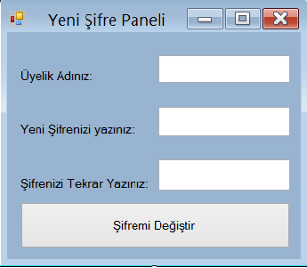

Imports System.Data.OleDb

Public Class Form3

Dim kaynak As String = "Provider=Microsoft.ACE.OLEDB.12.0;Data Source=uye_panel.accdb"

Private Sub Button1_Click(ByVal sender As System.Object, ByVal e As System.EventArgs) Handles Button1.Click

Dim komut As New OleDbCommand

Dim yol As String = Application.StartupPath.ToString()

Dim baglan As New OleDbConnection(kaynak)

baglan.Open()

komut.Connection = baglan

komut.CommandType = CommandType.Text

If TextBox2.Text = TextBox3.Text Then

komut.CommandText = ("Update tablo set uye_sifre='" + TextBox2.Text + "' where uye_adi='" + TextBox1.Text + "'")

komut.ExecuteNonQuery()

baglan.Close()

MessageBox.Show("Şifreniz başarıyla değiştirilmiştir.", "Şifre Değiştirme Uyarısı", MessageBoxButtons.OK, MessageBoxIcon.Exclamation)

Me.Close()

Form1.Show()

TextBox1.Clear()

TextBox2.Clear()

TextBox3.Clear()

Else

MessageBox.Show("Girmiş olduğunuz şifre uyuşmamaktadır. ", "Şifre Değiştirme Uyarısı", MessageBoxButtons.OK, MessageBoxIcon.Error)

Me.Show()

TextBox2.Clear()

TextBox3.Clear()

End If

End Sub

Private Sub Form3_FormClosed(ByVal sender As System.Object, ByVal e As System.Windows.Forms.FormClosedEventArgs) Handles MyBase.FormClosed

Form1.Show()

End Sub

End Class

FORM 4 KODLARI VE EKRAN YAPISI

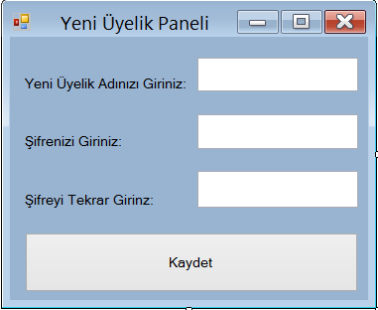

Imports System.Data.OleDb

Public Class Form4

Private Sub Button1_Click(ByVal sender As System.Object, ByVal e As System.EventArgs) Handles Button1.Click

Dim yol As String = Application.StartupPath.ToString()

Dim baglan As New OleDbConnection("Provider=Microsoft.ACE.OLEDB.12.0;Data Source=uye_panel.accdb")

Dim komut As New OleDbCommand

baglan.Open()

komut.Connection = baglan

komut.CommandType = CommandType.Text

If TextBox2.Text = TextBox3.Text Then

komut.CommandText = "INSERT INTO tablo (uye_adi,uye_sifre) values ('" + TextBox1.Text + "','" + TextBox2.Text + "')"

komut.ExecuteNonQuery()

baglan.Close()

MessageBox.Show("Kaydınız başarıyla yapılmıştır.", "Şifre Uyarısı", MessageBoxButtons.OK, MessageBoxIcon.Exclamation)

Me.Close()

Form1.Show()

TextBox1.Clear()

TextBox2.Clear()

TextBox3.Clear()

Else

MessageBox.Show("Girmiş olduğunuz şifre yanlıştır.", "Şifre Uyarısı", MessageBoxButtons.OK, MessageBoxIcon.Error)

Me.Show()

End If

End Sub

Private Sub Form4_FormClosed(ByVal sender As System.Object, ByVal e As System.Windows.Forms.FormClosedEventArgs) Handles MyBase.FormClosed

Form1.Show()

End Sub

End Class

FORM 5 KODLARI VE EKRAN YAPISI

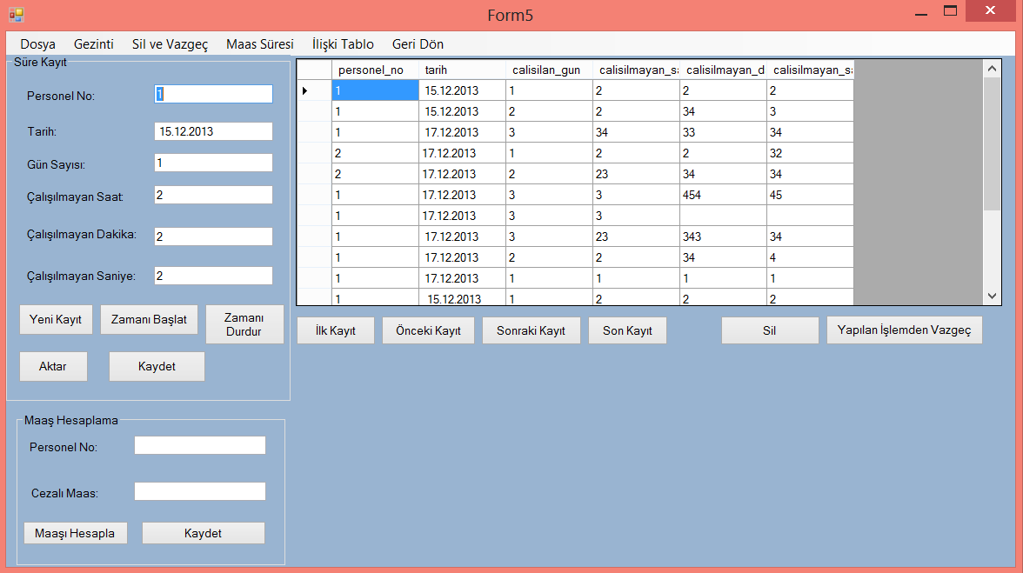

Imports System.Data.OleDb

Public Class Form5

Public saat As Double = 0

Public dakika As Double = 0

Public maas As Double = 0

Dim baglan As OleDbConnection

Dim komut As New OleDbCommand

Dim kaynak As String = "Provider=Microsoft.ACE.OLEDB.12.0;Data Source=proje.accdb"

Dim saa As Integer = 0

Dim dk As Integer = 0

Dim sny As Integer = 0

Public Sub saatler()

Dim baglan As New OleDbConnection(kaynak)

baglan.Open()

Dim command As New OleDbCommand("select sum(calisilmayan_saat) from hesap where personel_no=" & TextBox7.Text & " ", baglan)

saat = Convert.ToInt32(command.ExecuteScalar())

baglan.Close()

End Sub

Public Sub dakikalar()

Dim baglan As New OleDbConnection(kaynak)

baglan.Open()

Dim command As New OleDbCommand("select sum(calisilmayan_dakika) from hesap where personel_no = " & TextBox7.Text & " ", baglan)

dakika = Convert.ToInt32(command.ExecuteScalar())

baglan.Close()

End Sub

Public Sub maaslar()

Dim baglan As New OleDbConnection(kaynak)

baglan.Open()

Dim command As New OleDbCommand("select genel_maas from personel where personel_no= " & TextBox7.Text & " ", baglan)

maas = Convert.ToInt32(command.ExecuteScalar())

baglan.Close()

End Sub

Private Sub Timer1_Tick(ByVal sender As System.Object, ByVal e As System.EventArgs) Handles Timer1.Tick

sny = sny + 1

TextBox6.Text = sny

If sny = 59 Then

sny = 0

dk = dk + 1

TextBox5.Text = dk

If dk = 59 Then

dk = 0

saa = saa + 1

TextBox4.Text = saat

If saa = 7 Then

Timer1.Stop()

End If

End If

End If

End Sub

Private Sub Form5_Load(ByVal sender As System.Object, ByVal e As System.EventArgs) Handles MyBase.Load

Timer1.Interval = 1000

Dim baglan As New OleDbConnection(kaynak)

Dim adap As New OleDbDataAdapter("select * from hesap", baglan)

Dim tablo As New DataTable()

Dim ds As New DataSet()

adap.Fill(ds, "das")

ds.Tables.Add(tablo)

BindingSource1.DataSource = ds

BindingSource1.DataMember = ds.Tables(0).TableName

DataGridView1.DataSource = BindingSource1

TextBox1.DataBindings.Add("text", BindingSource1, "personel_no")

TextBox2.DataBindings.Add("text", BindingSource1, "tarih")

TextBox3.DataBindings.Add("text", BindingSource1, "calisilan_gun")

TextBox4.DataBindings.Add("text", BindingSource1, "calisilmayan_saat")

TextBox5.DataBindings.Add("text", BindingSource1, "calisilmayan_dakika")

TextBox6.DataBindings.Add("text", BindingSource1, "calisilmayan_saniye")

End Sub

Private Sub Button2_Click(ByVal sender As System.Object, ByVal e As System.EventArgs) Handles Button2.Click

Timer1.Stop()

Timer1.Enabled = False

End Sub

Private Sub SerialPort1_DataReceived(ByVal sender As System.Object, ByVal e As System.IO.Ports.SerialDataReceivedEventArgs) Handles SerialPort1.DataReceived

Timer1.Enabled = True

Timer1.Start()

End Sub

Private Sub SerialPort1_ErrorReceived(ByVal sender As System.Object, ByVal e As System.IO.Ports.SerialErrorReceivedEventArgs) Handles SerialPort1.ErrorReceived

Timer1.Stop()

End Sub

Private Sub Button3_Click(ByVal sender As System.Object, ByVal e As System.EventArgs) Handles Button3.Click

BindingSource1.AddNew()

TextBox2.Text = Date.Now.Date

TextBox4.Text = "00"

TextBox5.Text = "00"

TextBox6.Text = "00"

End Sub

Private Sub Button4_Click(ByVal sender As System.Object, ByVal e As System.EventArgs) Handles Button4.Click

BindingSource1.EndEdit()

End Sub

Private Sub Button6_Click(ByVal sender As System.Object, ByVal e As System.EventArgs) Handles Button6.Click

BindingSource1.MoveFirst()

End Sub

Private Sub Button7_Click(ByVal sender As System.Object, ByVal e As System.EventArgs) Handles Button7.Click

BindingSource1.MovePrevious()

End Sub

Private Sub Button8_Click(ByVal sender As System.Object, ByVal e As System.EventArgs) Handles Button8.Click

BindingSource1.MoveNext()

End Sub

Private Sub Button9_Click(ByVal sender As System.Object, ByVal e As System.EventArgs) Handles Button9.Click

BindingSource1.MoveLast()

End Sub

Private Sub Button10_Click(ByVal sender As System.Object, ByVal e As System.EventArgs) Handles Button10.Click

BindingSource1.RemoveAt(BindingSource1.Position)

End Sub

Private Sub Button11_Click(ByVal sender As System.Object, ByVal e As System.EventArgs) Handles Button11.Click

BindingSource1.CancelEdit()

End Sub

Private Sub Button1_Click(ByVal sender As System.Object, ByVal e As System.EventArgs) Handles Button1.Click

Timer1.Enabled = True

Timer1.Start()

End Sub

Private Sub Button12_Click(ByVal sender As System.Object, ByVal e As System.EventArgs) Handles Button12.Click

saatler()

dakikalar()

maaslar()

MsgBox(saat)

MsgBox(dakika)

MsgBox(maas)

Dim carp As Double

carp = 0

carp = saat * 60

carp = carp + dakika

Dim ort As Double

ort = 0

ort = maas / carp

MsgBox(ort)

Dim genel As Double

genel = 0

genel = maas - ort

TextBox8.Text = genel

End Sub

Private Sub TextBox1_KeyPress(ByVal sender As System.Object, ByVal e As System.Windows.Forms.KeyPressEventArgs) Handles TextBox1.KeyPress

If (Microsoft.VisualBasic.Asc(e.KeyChar) < 48) Or (Microsoft.VisualBasic.Asc(e.KeyChar) > 57) Then

e.Handled = True

End If

If (Microsoft.VisualBasic.Asc(e.KeyChar) = 8) Then

e.Handled = False

End If

End Sub

Private Sub TextBox2_KeyPress(ByVal sender As System.Object, ByVal e As System.Windows.Forms.KeyPressEventArgs) Handles TextBox2.KeyPress

If (Microsoft.VisualBasic.Asc(e.KeyChar) < 48) Or (Microsoft.VisualBasic.Asc(e.KeyChar) > 57) Then

e.Handled = True

End If

If (Microsoft.VisualBasic.Asc(e.KeyChar) = 8) Then

e.Handled = False

End If

End Sub

Private Sub TextBox3_KeyPress(ByVal sender As System.Object, ByVal e As System.Windows.Forms.KeyPressEventArgs) Handles TextBox3.KeyPress

If (Microsoft.VisualBasic.Asc(e.KeyChar) < 48) Or (Microsoft.VisualBasic.Asc(e.KeyChar) > 57) Then

e.Handled = True

End If

If (Microsoft.VisualBasic.Asc(e.KeyChar) = 8) Then

e.Handled = False

End If

End Sub

Private Sub TextBox4_KeyPress(ByVal sender As System.Object, ByVal e As System.Windows.Forms.KeyPressEventArgs) Handles TextBox4.KeyPress

If (Microsoft.VisualBasic.Asc(e.KeyChar) < 48) Or (Microsoft.VisualBasic.Asc(e.KeyChar) > 57) Then

e.Handled = True

End If

If (Microsoft.VisualBasic.Asc(e.KeyChar) = 8) Then

e.Handled = False

End If

End Sub

Private Sub TextBox5_KeyPress(ByVal sender As System.Object, ByVal e As System.Windows.Forms.KeyPressEventArgs) Handles TextBox5.KeyPress

If (Microsoft.VisualBasic.Asc(e.KeyChar) < 48) Or (Microsoft.VisualBasic.Asc(e.KeyChar) > 57) Then

e.Handled = True

End If

If (Microsoft.VisualBasic.Asc(e.KeyChar) = 8) Then

e.Handled = False

End If

End Sub

Private Sub TextBox6_KeyPress(ByVal sender As System.Object, ByVal e As System.Windows.Forms.KeyPressEventArgs) Handles TextBox6.KeyPress

If (Microsoft.VisualBasic.Asc(e.KeyChar) < 48) Or (Microsoft.VisualBasic.Asc(e.KeyChar) > 57) Then

e.Handled = True

End If

If (Microsoft.VisualBasic.Asc(e.KeyChar) = 8) Then

e.Handled = False

End If

End Sub

Private Sub TextBox7_KeyPress(ByVal sender As System.Object, ByVal e As System.Windows.Forms.KeyPressEventArgs) Handles TextBox7.KeyPress

If (Microsoft.VisualBasic.Asc(e.KeyChar) < 48) Or (Microsoft.VisualBasic.Asc(e.KeyChar) > 57) Then

e.Handled = True

End If

If (Microsoft.VisualBasic.Asc(e.KeyChar) = 8) Then

e.Handled = False

End If

End Sub

Private Sub TextBox8_KeyPress(ByVal sender As System.Object, ByVal e As System.Windows.Forms.KeyPressEventArgs) Handles TextBox8.KeyPress

If (Microsoft.VisualBasic.Asc(e.KeyChar) < 48) Or (Microsoft.VisualBasic.Asc(e.KeyChar) > 57) Then

e.Handled = True

End If

If (Microsoft.VisualBasic.Asc(e.KeyChar) = 8) Then

e.Handled = False

End If

End Sub

Private Sub ÇıkışToolStripMenuItem_Click(ByVal sender As System.Object, ByVal e As System.EventArgs) Handles ÇıkışToolStripMenuItem.Click

Select Case MessageBox.Show("Çıkmak İstiyormusunuz?", "Çıkış Uyarısı", MessageBoxButtons.YesNo, MessageBoxIcon.Question)

Case DialogResult.Yes

Application.Exit()

Case Else

Me.Show()

End Select

End Sub

Private Sub GeriDönToolStripMenuItem1_Click(ByVal sender As System.Object, ByVal e As System.EventArgs) Handles GeriDönToolStripMenuItem1.Click

Me.Close()

Form2.Show()

End Sub

Private Sub İlişkiTabloAçToolStripMenuItem_Click(ByVal sender As System.Object, ByVal e As System.EventArgs) Handles İlişkiTabloAçToolStripMenuItem.Click

Form8.ShowDialog()

End Sub

Private Sub Button5_Click(ByVal sender As System.Object, ByVal e As System.EventArgs) Handles Button5.Click

Dim yol As String = Application.StartupPath.ToString()

Dim baglan As New OleDbConnection(kaynak)

baglan.Open()

komut.Connection = baglan

komut.CommandType = CommandType.Text

If TextBox1.Text <> "" And TextBox2.Text <> "" And TextBox3.Text <> "" And TextBox4.Text <> "" And TextBox5.Text <> "" And TextBox6.Text <> "" Then

komut.CommandText = "insert into hesap (personel_no,tarih,calisilan_gun,calisilmayan_saat,calisilmayan_dakika,calisilmayan_saniye) values ( " & CInt(TextBox1.Text) & " , ' " & TextBox2.Text & " ' , " & CInt(TextBox3.Text) & " , " & CInt(TextBox4.Text) & " , " & CInt(TextBox5.Text) & " , " & CInt(TextBox6.Text) & " ) "

komut.ExecuteNonQuery()

TextBox1.Clear()

TextBox2.Clear()

TextBox3.Clear()

TextBox4.Clear()

TextBox5.Clear()

TextBox6.Clear()

MessageBox.Show("Kayıt Yapıldı..")

Else

MessageBox.Show("Lütfen Boşlukları Doldurunuz")

End If

baglan.Close()

End Sub

Private Sub Button13_Click(ByVal sender As System.Object, ByVal e As System.EventArgs) Handles Button13.Click

Dim yol As String = Application.StartupPath.ToString()

Dim baglan As New OleDbConnection(kaynak)

baglan.Open()

komut.Connection = baglan

komut.CommandType = CommandType.Text

komut.CommandType = CommandType.Text

If TextBox7.Text <> "" And TextBox8.Text Then

komut.CommandText = "Update personel set cezali_maas = " & CInt(TextBox2.Text) & " where personel_no= " & CInt(TextBox8.Text) & " "

komut.ExecuteNonQuery()

TextBox7.Clear()

TextBox8.Clear()

MessageBox.Show("Kayıt Yapıldı..")

End

Else

MessageBox.Show("Lütfen Boşlukları Doldurunuz")

End If

baglan.Close()

End Sub

End Class

FORM 6 KODLARI VE EKRAN YAPISI

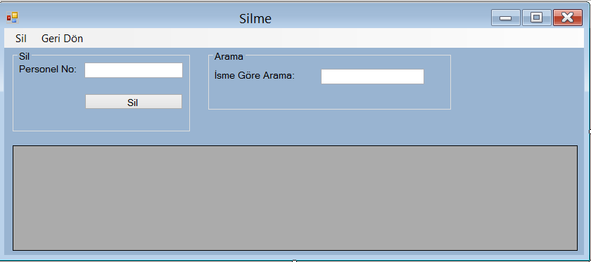

Imports System.Data.OleDb

Public Class Form6

Dim kaynak As String = " Provider=Microsoft.ACE.OLEDB.12.0;Data Source = proje.accdb "

Private Sub Form6_Load(ByVal sender As System.Object, ByVal e As System.EventArgs) Handles MyBase.Load

Dim baglan As New OleDbConnection(kaynak)

Dim adap As New OleDbDataAdapter("select * from personel", baglan)

Dim tablo As New DataTable()

Dim ds As New DataSet()

adap.Fill(ds, "tablo")

ds.Tables.Add(tablo)

BindingSource1.DataSource = ds

BindingSource1.DataMember = ds.Tables(0).TableName

DataGridView1.DataSource = BindingSource1

End Sub

Private Sub Button1_Click(ByVal sender As System.Object, ByVal e As System.EventArgs) Handles Button1.Click

Dim yol As String = Application.StartupPath.ToString()

Dim baglan As New OleDbConnection(kaynak)

Dim komut As New OleDbCommand

baglan.Open()

komut.Connection = baglan

komut.CommandType = CommandType.Text

komut.CommandText = "delete from personel where personel_no = " & CInt(TextBox1.Text) & " "

BindingSource1.RemoveCurrent()

komut.ExecuteNonQuery()

MsgBox("Kayıt Silindi")

baglan.Close()

DataGridView1.Refresh()

Dim adap As New OleDbDataAdapter("select * from personel", baglan)

Dim tablo As New DataTable()

Dim ds As New DataSet()

adap.Fill(ds, "tablo")

ds.Tables.Add(tablo)

BindingSource1.DataSource = ds

BindingSource1.DataMember = ds.Tables(0).TableName

DataGridView1.DataSource = BindingSource1

End Sub

Private Sub TextBox1_KeyPress(ByVal sender As System.Object, ByVal e As System.Windows.Forms.KeyPressEventArgs) Handles TextBox1.KeyPress

If (Microsoft.VisualBasic.Asc(e.KeyChar) < 48) Or (Microsoft.VisualBasic.Asc(e.KeyChar) > 57) Then

e.Handled = True

End If

If (Microsoft.VisualBasic.Asc(e.KeyChar) = 8) Then

e.Handled = False

End If

End Sub

Private Sub ÇıkışToolStripMenuItem_Click(ByVal sender As System.Object, ByVal e As System.EventArgs) Handles ÇıkışToolStripMenuItem.Click

Me.Close()

End Sub

Private Sub SilToolStripMenuItem_Click(ByVal sender As System.Object, ByVal e As System.EventArgs) Handles SilToolStripMenuItem.Click

Dim yol As String = Application.StartupPath.ToString()

Dim baglan As New OleDbConnection(kaynak)

Dim komut As New OleDbCommand

baglan.Open()

komut.Connection = baglan

komut.CommandType = CommandType.Text

komut.CommandText = "delete from personel where personel_no = " & CInt(TextBox1.Text) & " "

BindingSource1.RemoveCurrent()

komut.ExecuteNonQuery()

MsgBox("Kayıt Silindi")

baglan.Close()

DataGridView1.Refresh()

Dim adap As New OleDbDataAdapter("select * from personel", baglan)

Dim tablo As New DataTable()

Dim ds As New DataSet()

adap.Fill(ds, "tablo")

ds.Tables.Add(tablo)

BindingSource1.DataSource = ds

BindingSource1.DataMember = ds.Tables(0).TableName

DataGridView1.DataSource = BindingSource1

End Sub

Private Sub TextBox2_KeyPress(ByVal sender As System.Object, ByVal e As System.Windows.Forms.KeyPressEventArgs)

If Not (Char.IsLetter(e.KeyChar) = True) And e.KeyChar <> ChrW(Keys.Back) And e.KeyChar <> ChrW(Keys.Space) Then

e.Handled = True

End If

End Sub

Private Sub TextBox2_TextChanged(ByVal sender As System.Object, ByVal e As System.EventArgs) Handles TextBox2.TextChanged

Dim baglan As New OleDbConnection(kaynak)

baglan.Open()

Dim adap As New OleDbDataAdapter("select * from personel where adi like'%" & TextBox2.Text & "%'", baglan)

Dim tablo As New DataTable

adap.Fill(tablo)

Dim data As New DataSet

data.Tables.Add(tablo)

BindingSource1.DataSource = data.Tables(0)

DataGridView1.DataSource = BindingSource1

baglan.Close()

End Sub

End Class

FORM 7 KODLARI VE EKRAN YAPISI

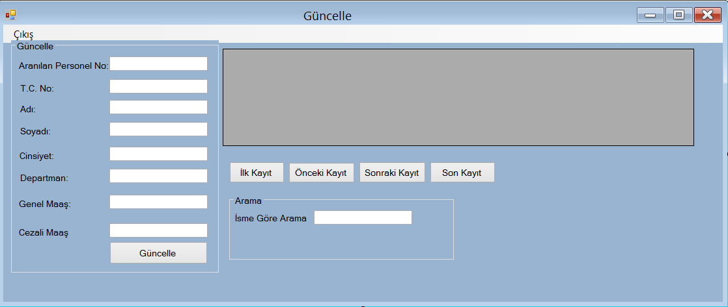

Imports System.Data.OleDb

Public Class Form7

Dim kaynak As String = "Provider=Microsoft.ACE.Oledb.12.0;Data Source=proje.accdb"

Private Sub Form7_Load(ByVal sender As System.Object, ByVal e As System.EventArgs) Handles MyBase.Load

TextBox2.MaxLength = 11

Dim baglan As New OleDbConnection(kaynak)

Dim adap As New OleDbDataAdapter("select * from personel", kaynak)

Dim tablo As New DataTable()

Dim ds As New DataSet()

adap.Fill(ds, "tablo")

ds.Tables.Add(tablo)

BindingSource1.DataSource = ds

BindingSource1.DataMember = ds.Tables(0).TableName

DataGridView1.DataSource = BindingSource1

End Sub

Private Sub Button1_Click(ByVal sender As System.Object, ByVal e As System.EventArgs) Handles Button1.Click

Dim yol As String = Application.StartupPath.ToString()

Dim baglan As New OleDbConnection(kaynak)

Dim komut As New OleDbCommand

baglan.Open()

komut.Connection = baglan

komut.CommandType = CommandType.Text

komut.CommandText = ("Update personel set tc_no = " & CInt(TextBox2.Text) & " , adi = ' " & TextBox3.Text & " ' , soyadi = ' " & TextBox4.Text & " ' , cinsiyet = ' " & TextBox5.Text & " ', departman = ' " & TextBox6.Text & " ' , genel_maas = " & CInt(TextBox7.Text) & " , cezali_maas = " & CInt(TextBox8.Text) & " where personel_no = " & CInt(TextBox1.Text) & " ")

komut.ExecuteNonQuery()

baglan.Close()

DataGridView1.Refresh()

End Sub

Private Sub Button4_Click(ByVal sender As System.Object, ByVal e As System.EventArgs) Handles Button4.Click

BindingSource1.MoveFirst()

End Sub

Private Sub Button6_Click(ByVal sender As System.Object, ByVal e As System.EventArgs) Handles Button6.Click

BindingSource1.MovePrevious()

End Sub

Private Sub Button5_Click(ByVal sender As System.Object, ByVal e As System.EventArgs) Handles Button5.Click

BindingSource1.MoveNext()

End Sub

Private Sub Button7_Click(ByVal sender As System.Object, ByVal e As System.EventArgs) Handles Button7.Click

BindingSource1.MoveLast()

End Sub

Private Sub TextBox1_KeyPress(ByVal sender As System.Object, ByVal e As System.Windows.Forms.KeyPressEventArgs) Handles TextBox1.KeyPress

If (Microsoft.VisualBasic.Asc(e.KeyChar) < 48) Or (Microsoft.VisualBasic.Asc(e.KeyChar) > 57) Then

e.Handled = True

End If

If (Microsoft.VisualBasic.Asc(e.KeyChar) = 8) Then

e.Handled = False

End If

End Sub

Private Sub TextBox2_KeyPress(ByVal sender As System.Object, ByVal e As System.Windows.Forms.KeyPressEventArgs) Handles TextBox2.KeyPress

If (Microsoft.VisualBasic.Asc(e.KeyChar) < 48) Or (Microsoft.VisualBasic.Asc(e.KeyChar) > 57) Then

e.Handled = True

End If

If (Microsoft.VisualBasic.Asc(e.KeyChar) = 8) Then

e.Handled = False

End If

End Sub

Private Sub TextBox8_KeyPress(ByVal sender As System.Object, ByVal e As System.Windows.Forms.KeyPressEventArgs) Handles TextBox8.KeyPress

If (Microsoft.VisualBasic.Asc(e.KeyChar) < 48) Or (Microsoft.VisualBasic.Asc(e.KeyChar) > 57) Then

e.Handled = True

End If

If (Microsoft.VisualBasic.Asc(e.KeyChar) = 8) Then

e.Handled = False

End If

End Sub

Private Sub TextBox3_KeyPress(ByVal sender As System.Object, ByVal e As System.Windows.Forms.KeyPressEventArgs) Handles TextBox3.KeyPress

If Not (Char.IsLetter(e.KeyChar) = True) And e.KeyChar <> ChrW(Keys.Back) And e.KeyChar <> ChrW(Keys.Space) Then

e.Handled = True

End If

End Sub

Private Sub TextBox4_KeyPress(ByVal sender As System.Object, ByVal e As System.Windows.Forms.KeyPressEventArgs) Handles TextBox4.KeyPress

If Not (Char.IsLetter(e.KeyChar) = True) And e.KeyChar <> ChrW(Keys.Back) And e.KeyChar <> ChrW(Keys.Space) Then

e.Handled = True

End If

End Sub

Private Sub TextBox5_KeyPress(ByVal sender As System.Object, ByVal e As System.Windows.Forms.KeyPressEventArgs) Handles TextBox5.KeyPress

If Not (Char.IsLetter(e.KeyChar) = True) And e.KeyChar <> ChrW(Keys.Back) And e.KeyChar <> ChrW(Keys.Space) Then

e.Handled = True

End If

End Sub

Private Sub TextBox7_KeyPress(ByVal sender As System.Object, ByVal e As System.Windows.Forms.KeyPressEventArgs) Handles TextBox7.KeyPress

If (Microsoft.VisualBasic.Asc(e.KeyChar) < 48) Or (Microsoft.VisualBasic.Asc(e.KeyChar) > 57) Then

e.Handled = True

End If

If (Microsoft.VisualBasic.Asc(e.KeyChar) = 8) Then

e.Handled = False

End If

End Sub

Private Sub TextBox6_KeyPress(ByVal sender As System.Object, ByVal e As System.Windows.Forms.KeyPressEventArgs) Handles TextBox6.KeyPress

If Not (Char.IsLetter(e.KeyChar) = True) And e.KeyChar <> ChrW(Keys.Back) And e.KeyChar <> ChrW(Keys.Space) Then

e.Handled = True

End If

End Sub

Private Sub ÇıkışToolStripMenuItem_Click(ByVal sender As System.Object, ByVal e As System.EventArgs) Handles ÇıkışToolStripMenuItem.Click

Me.Close()

End Sub

Private Sub TextBox9_TextChanged(ByVal sender As System.Object, ByVal e As System.EventArgs) Handles TextBox9.TextChanged

Dim baglan As New OleDbConnection(kaynak)

baglan.Open()

Dim adap As New OleDbDataAdapter("select * from musteri where adi like'%" & TextBox9.Text & "%'", baglan)

Dim tablo As New DataTable

adap.Fill(tablo)

Dim data As New DataSet

data.Tables.Add(tablo)

BindingSource1.DataSource = data.Tables(0)

DataGridView1.DataSource = BindingSource1

baglan.Close()

End Sub

Private Sub TextBox9_KeyPress(ByVal sender As System.Object, ByVal e As System.Windows.Forms.KeyPressEventArgs) Handles TextBox9.KeyPress

If Not (Char.IsLetter(e.KeyChar) = True) And e.KeyChar <> ChrW(Keys.Back) And e.KeyChar <> ChrW(Keys.Space) Then

e.Handled = True

End If

End Sub

End Class

FORM 8 KODLARI VE EKRAN YAPISI

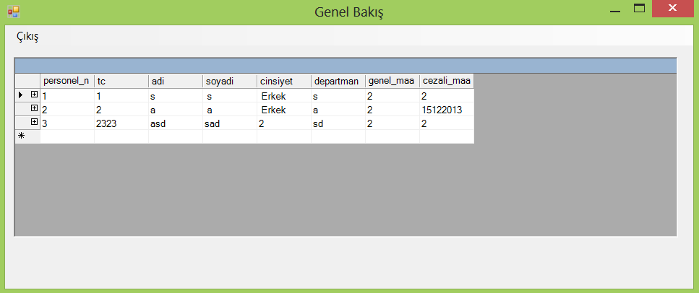

Imports System.Data.OleDb

Public Class Form8

Private Sub Form8_Load(ByVal sender As System.Object, ByVal e As System.EventArgs) Handles MyBase.Load

Dim baglan As New OleDbConnection("Provider=Microsoft.ACE.Oledb.12.0 ; Data Source=proje.accdb")

Dim adap As New OleDbDataAdapter

Dim ds As New DataSet

adap = New OleDb.OleDbDataAdapter("select * from personel", baglan)

adap.fill(ds, "tablo1")

adap = New OleDb.OleDbDataAdapter("select * from hesap", baglan)

adap.fill(ds, "tablo2")

Dim anatablo As DataColumn

Dim yavrutablo As DataColumn

anatablo = ds.Tables("tablo1").Columns("personel_no")

yavrutablo = ds.Tables("tablo2").Columns("personel_no")

Dim iliski As New DataRelation("Per", anatablo, yavrutablo)

ds.Relations.Add(iliski)

DataGrid1.DataSource = ds.Tables("tablo1")

End Sub

Private Sub ÇıkışToolStripMenuItem_Click(ByVal sender As System.Object, ByVal e As System.EventArgs) Handles ÇıkışToolStripMenuItem.Click

Me.Close()

End Sub

End Class